Citibike Analysis

# Overview:

## Purpose:

The purpose of the challenge is to provide data from the New York City bike sharing program to investors who are considering supporting such a program in Des Moines, Iowa. New York City data was downloaded from the month of August and analyzed using Tableau. The key questions we tried to answer for the investors buy using Tableau were:

* What are the lengths of time bikes are checked out for all riders and genders?
* What are the number of bike trips for all riders and genders each hour of each day of the week?
* What are the number of bike trips for each type of user and gender for each day of the week?

# Results:

* The chart indicates most trip duration are 5 minutes to 45 minutes.

* The chart identifies the duration by each gender.

* Indicated number of bike trips by all users each day of the week.

* Indicates number of bike trips by gender.

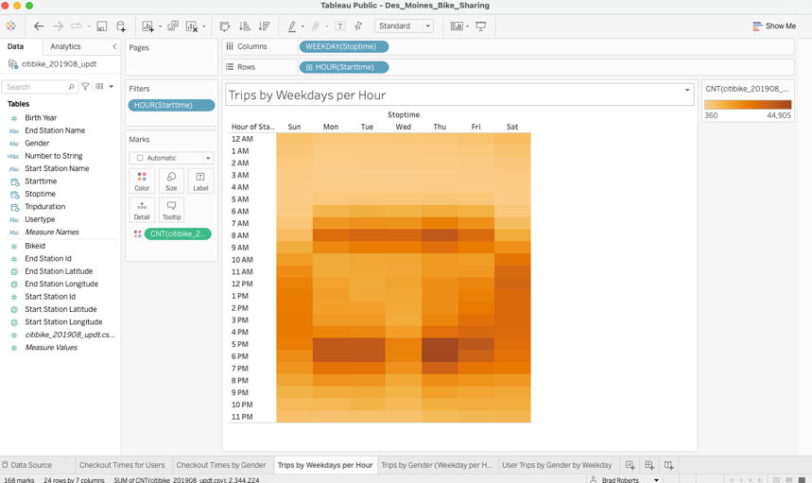

* Indicates number of trips by gender per hour of the weekday.

* Indicates trips by gender by weekday.

* Image of CitiBike Dashboard.

# Summary:

The analysis is to provide investors data as to how to view the Des Moines bike sharing program. The data indicates that males would be the target audience because the show more usage of the program. The program should have an appealing subscription to maintain more use of the program.

# Suggestions:

I would recommend providing data on age of users of the program. They need to have better data to indicate best time for maintenance of the bikes. Also a look at the overall usage of all months to know how when to lower the volume of bikes at the stations.